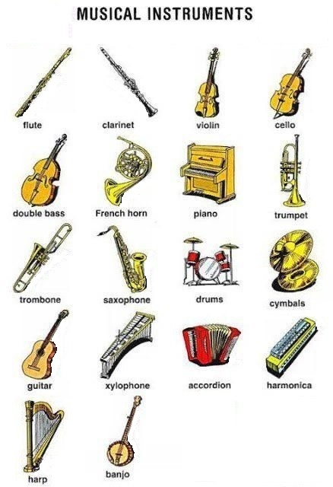

Wind: _________________________________________________________

Percussion: _________________________________________________________

String: _________________________________________________________

